Dairy Product Sales Analysis All over Tamil Nadu
Step1:
Removing Duplicates
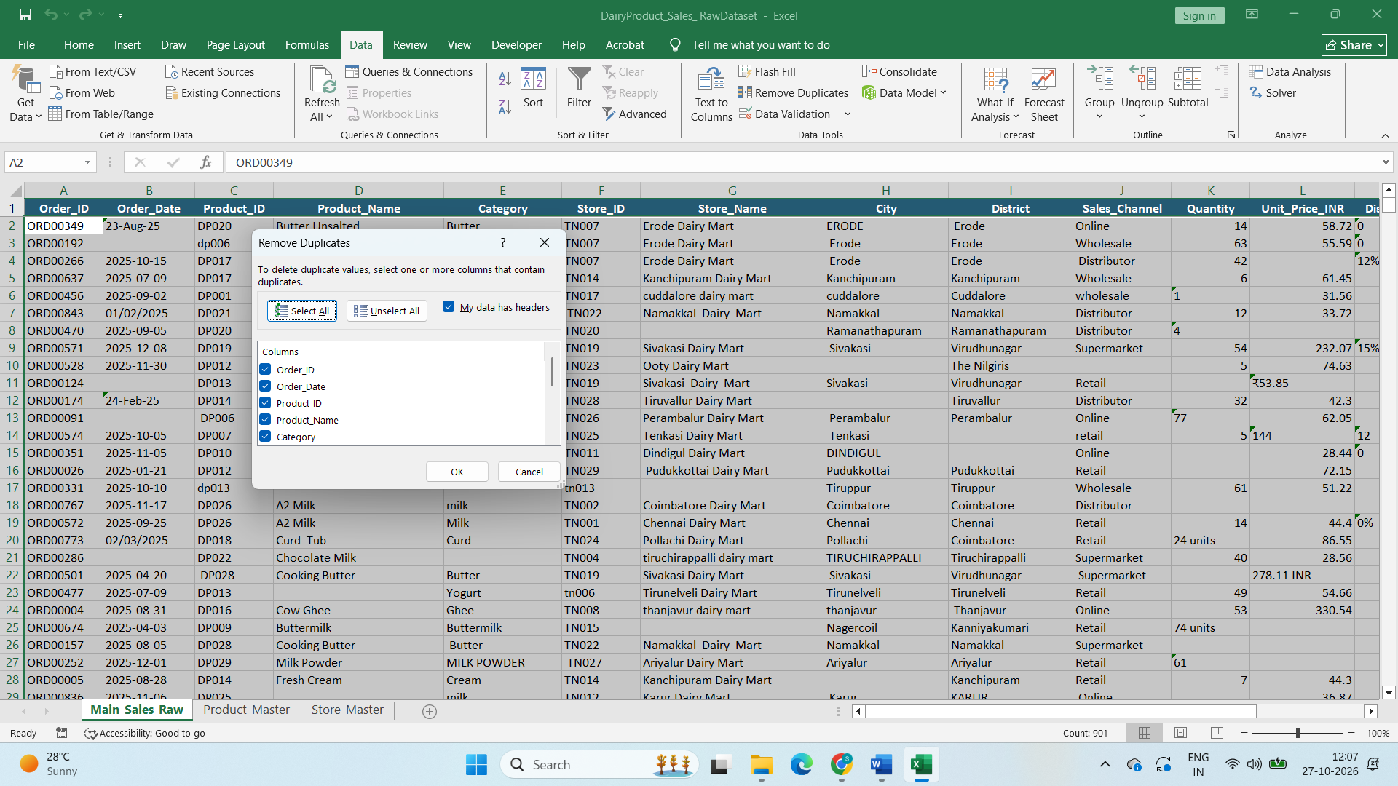

- Selected Data tab and selected Remove Duplicates under Data Tools and expand selection and select all columns to remove the Duplicates.

Correcting Formatting Errors
Step2:

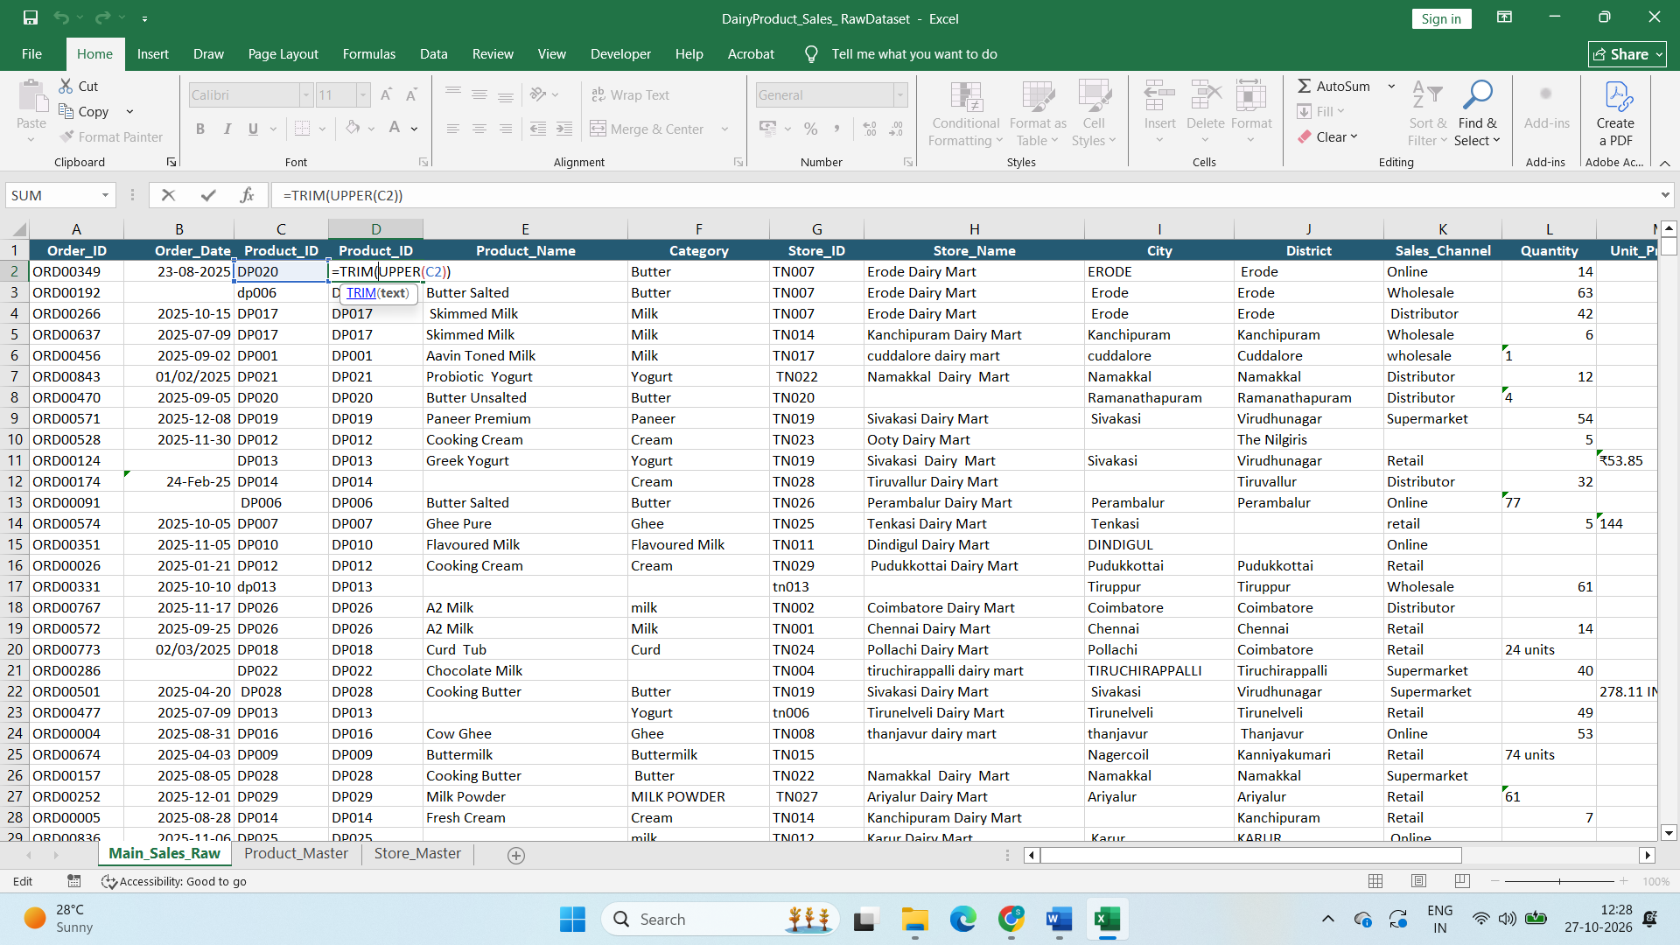* Crated new column next to Product ID and Used Trim and Upper Function to correct Format Error in Product ID Column and Deleted the existing colum

Step3:
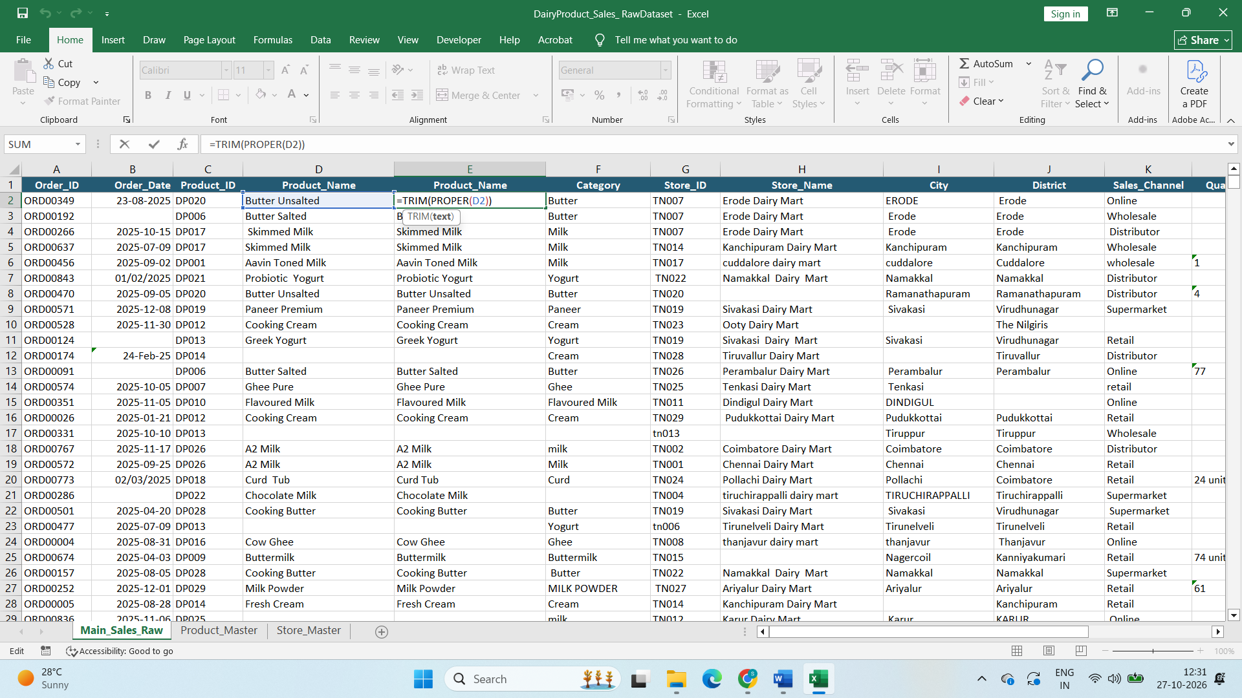
* Crated new column next to Product Name and Used Trim and Proper Function to correct Format
Error in Product Name Column and Deleted the existing column
Step4:
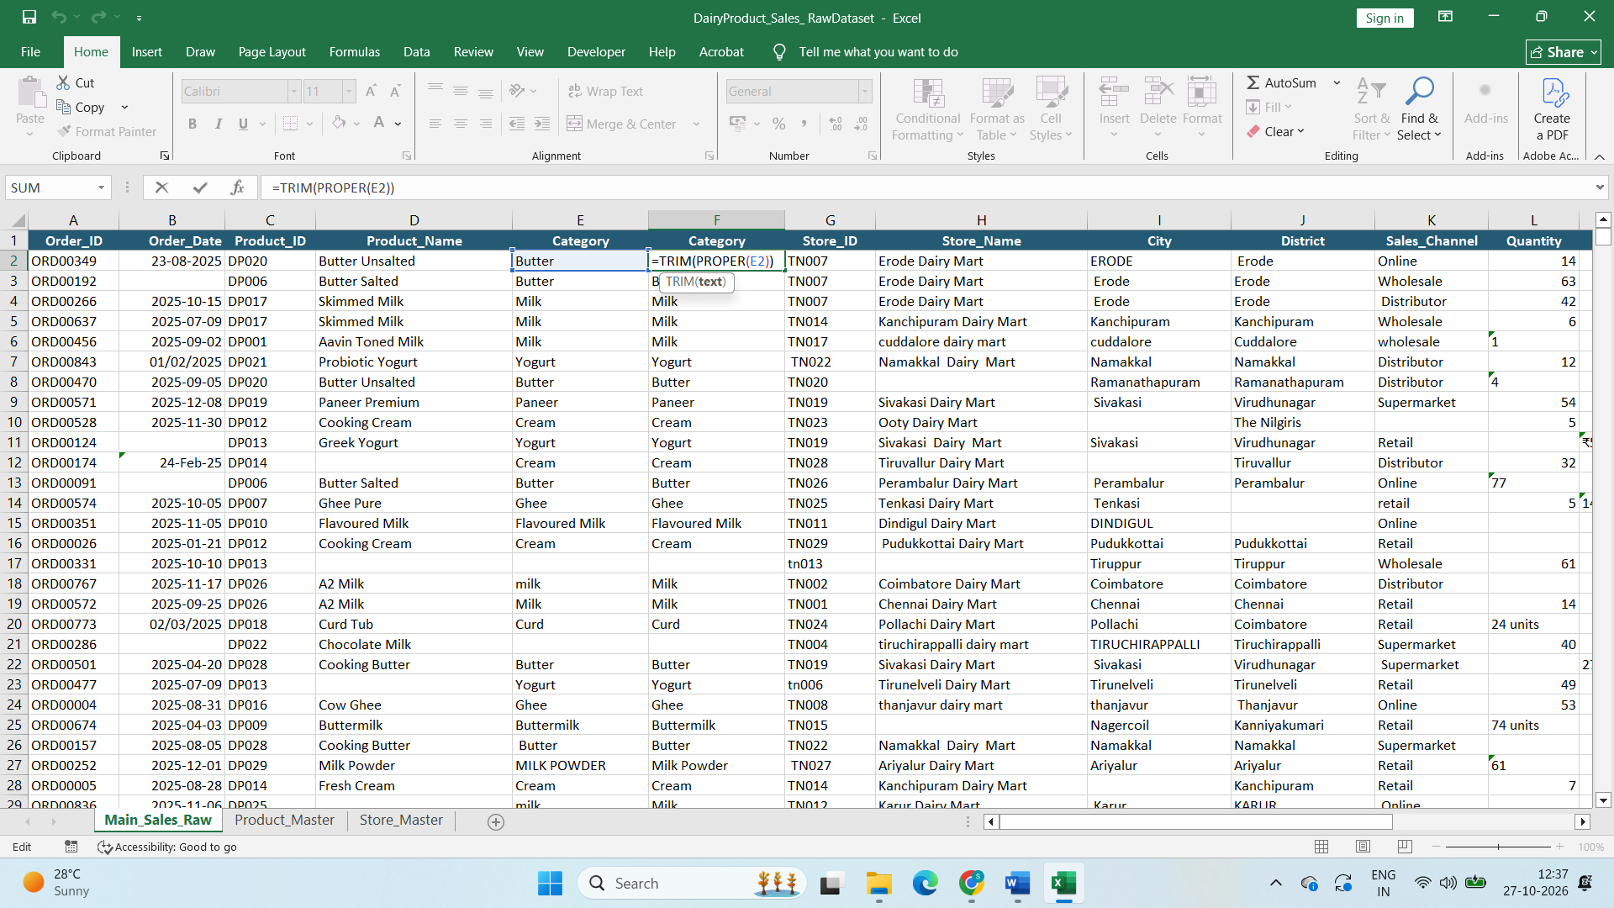
* Crated new column next to Category and Used Trim and Proper Function to correct Format
Error in Category Column and Deleted the existing column
Step5:
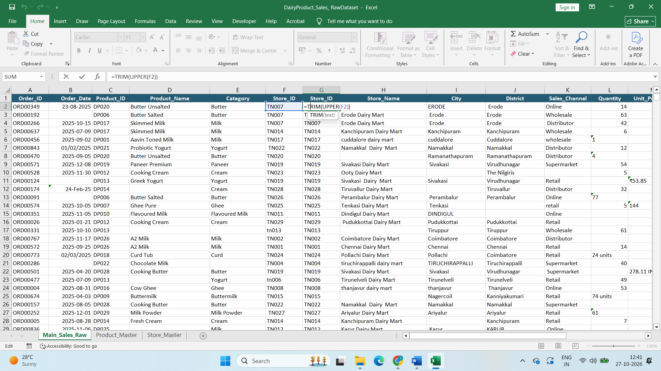
* Crated new column next to Store ID and Used Trim and Proper Function to correct Format
Error in Store ID Column and Deleted the existing column and Same method used for all Required column need to correct the format Error
Step6:
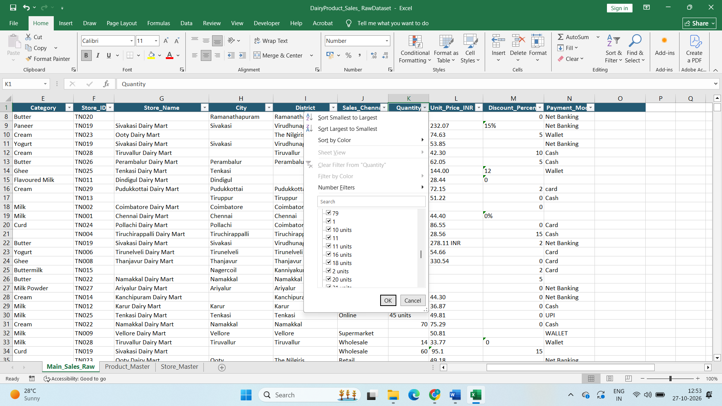
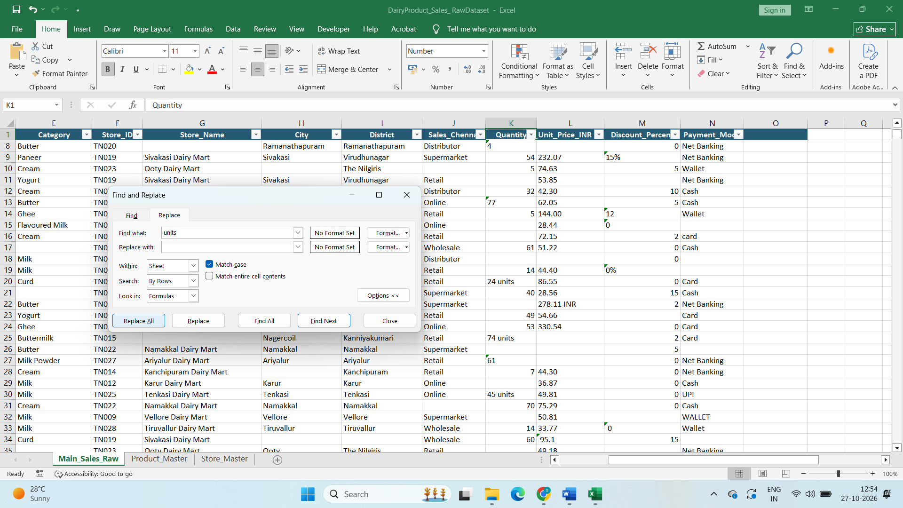
Checking on Filter found units in Quantity column and INR in Unit price column. Hence using find and and replace all functions replace units and INR
Step7:
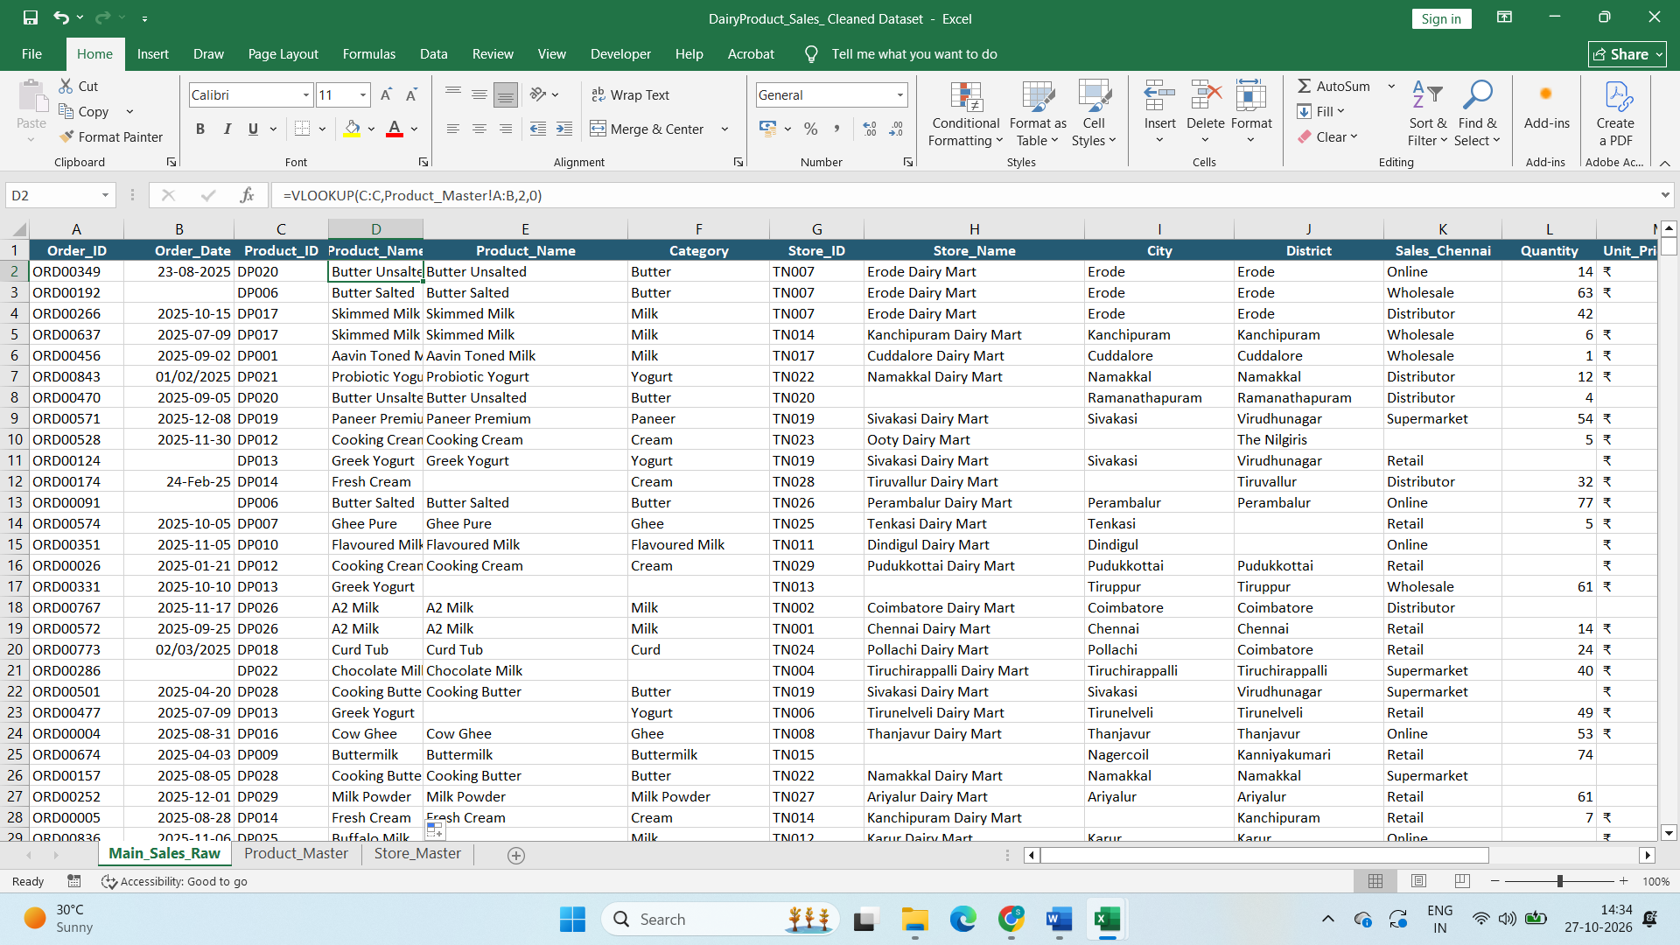
Finding the Missing Product Name : Created duplicate column and used Vlookup from sales data product ID with product Master Product ID =VLOOKUP(C:C,Product_Master!A:B,2,0) and deleted the Existing column
Step8:
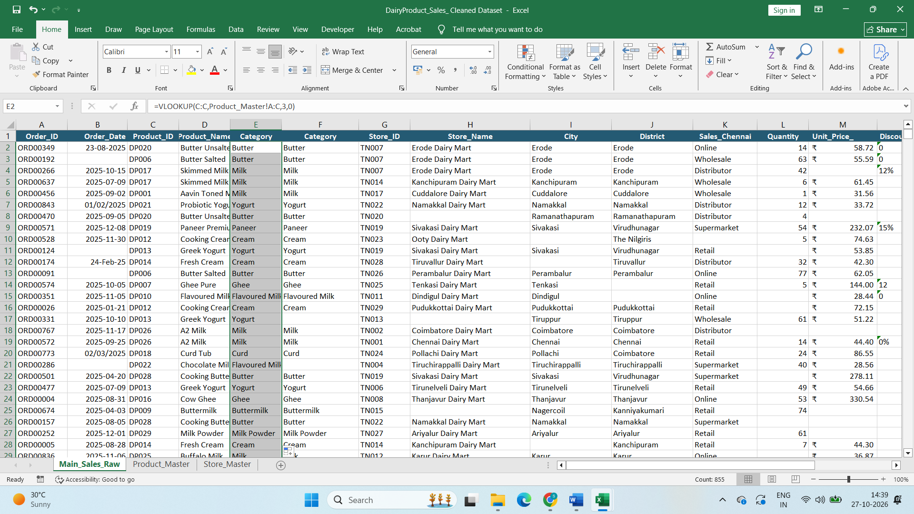
Finding the Missing Category : Created duplicate column and used Vlookup from sales data Category with product Master Category =VLOOKUP(C:C,Product_Master!A:C,3,0) and deleted the Existing column
Step 9:
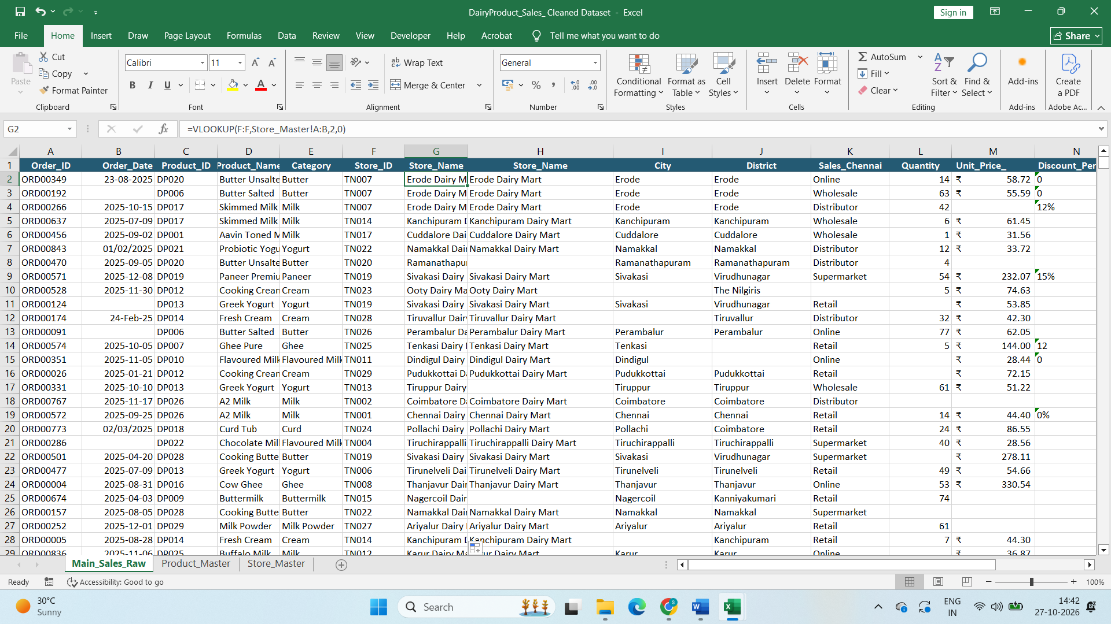
Finding the Missing Store Name : Created duplicate column and used Vlookup from sales data Store ID with Store Master Store ID =VLOOKUP(F:F,Store_Master!A:B,2,0)and deleted the Existing column
Step10
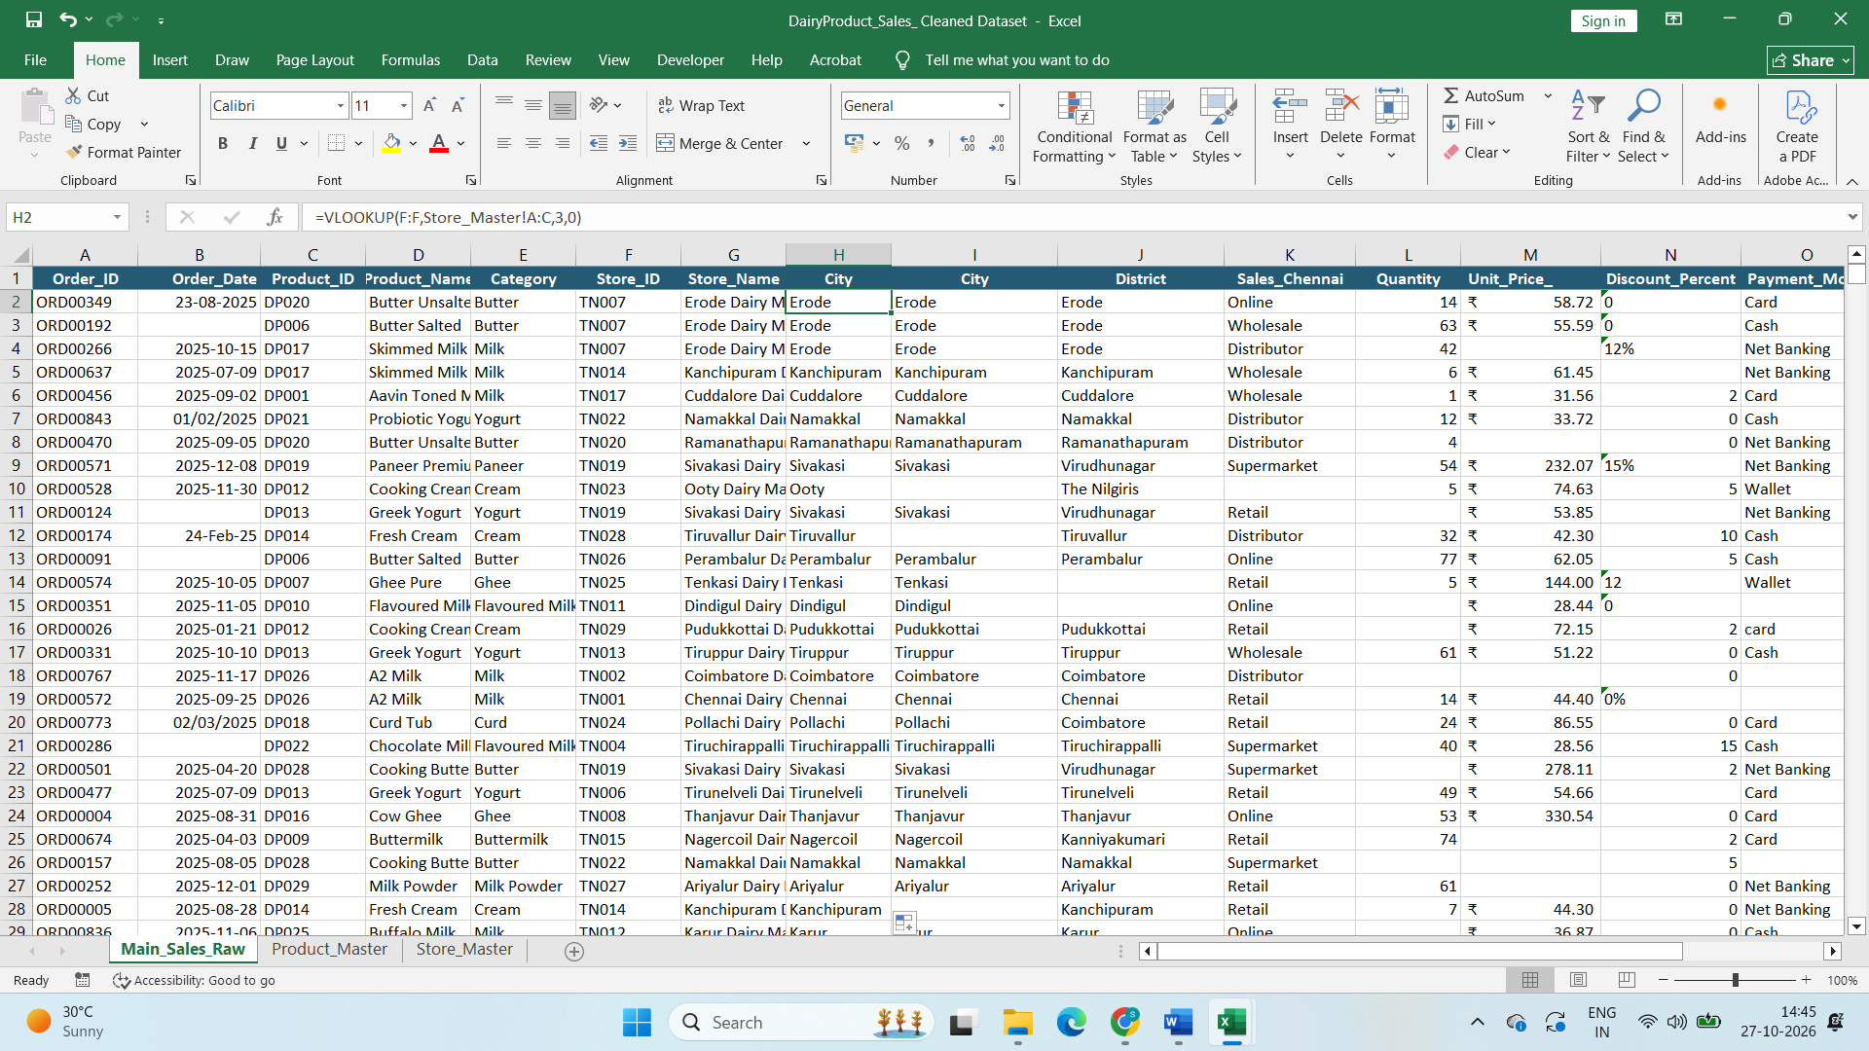
Finding the Missing City : Created duplicate column and used Vlookup from sales data Store ID with product Master Store ID =VLOOKUP(=VLOOKUP(F:F,Store_Master!A:C,3,0)) and deleted the Existing column
Step11:
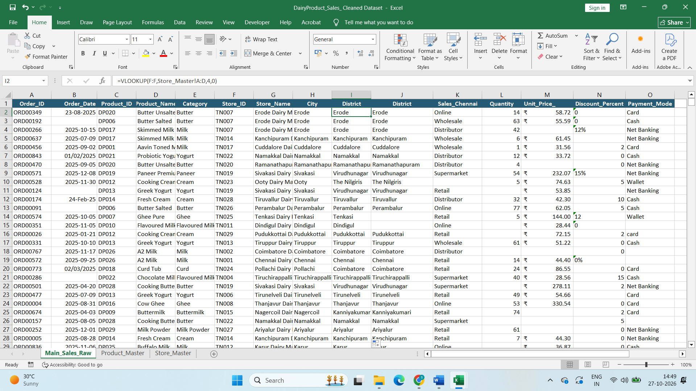
Finding the Missing District : Created duplicate column and used Vlookup from sales data Store ID with product Master Store ID =VLOOKUP(=VLOOKUP(F:F,Store_Master!A:D,4,0)) and deleted the Existing column
Step12:
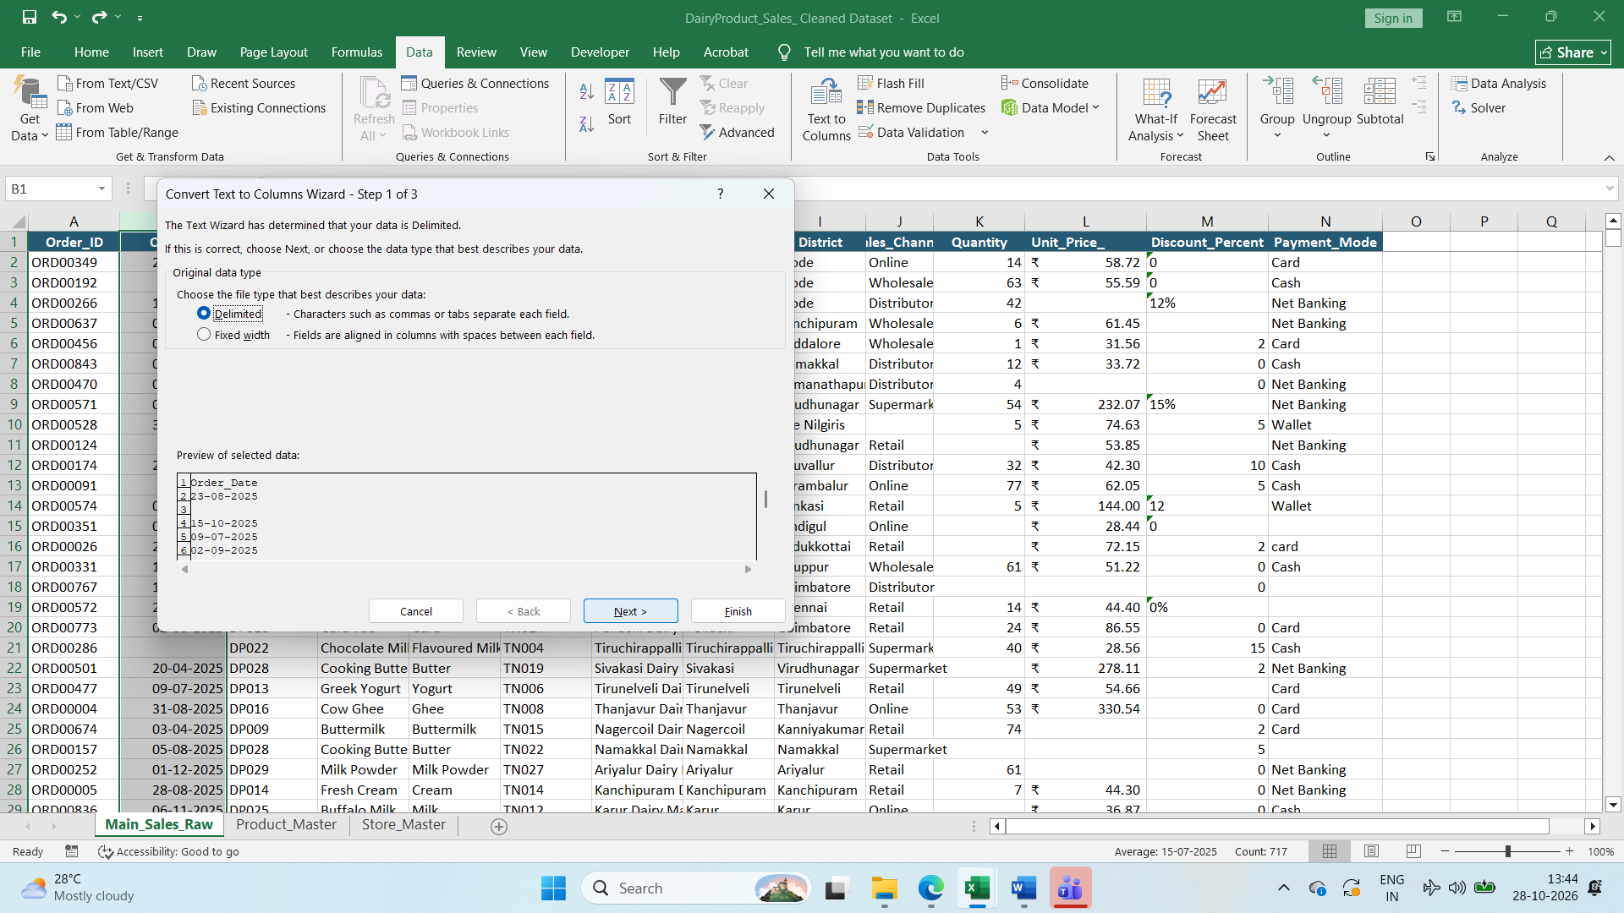
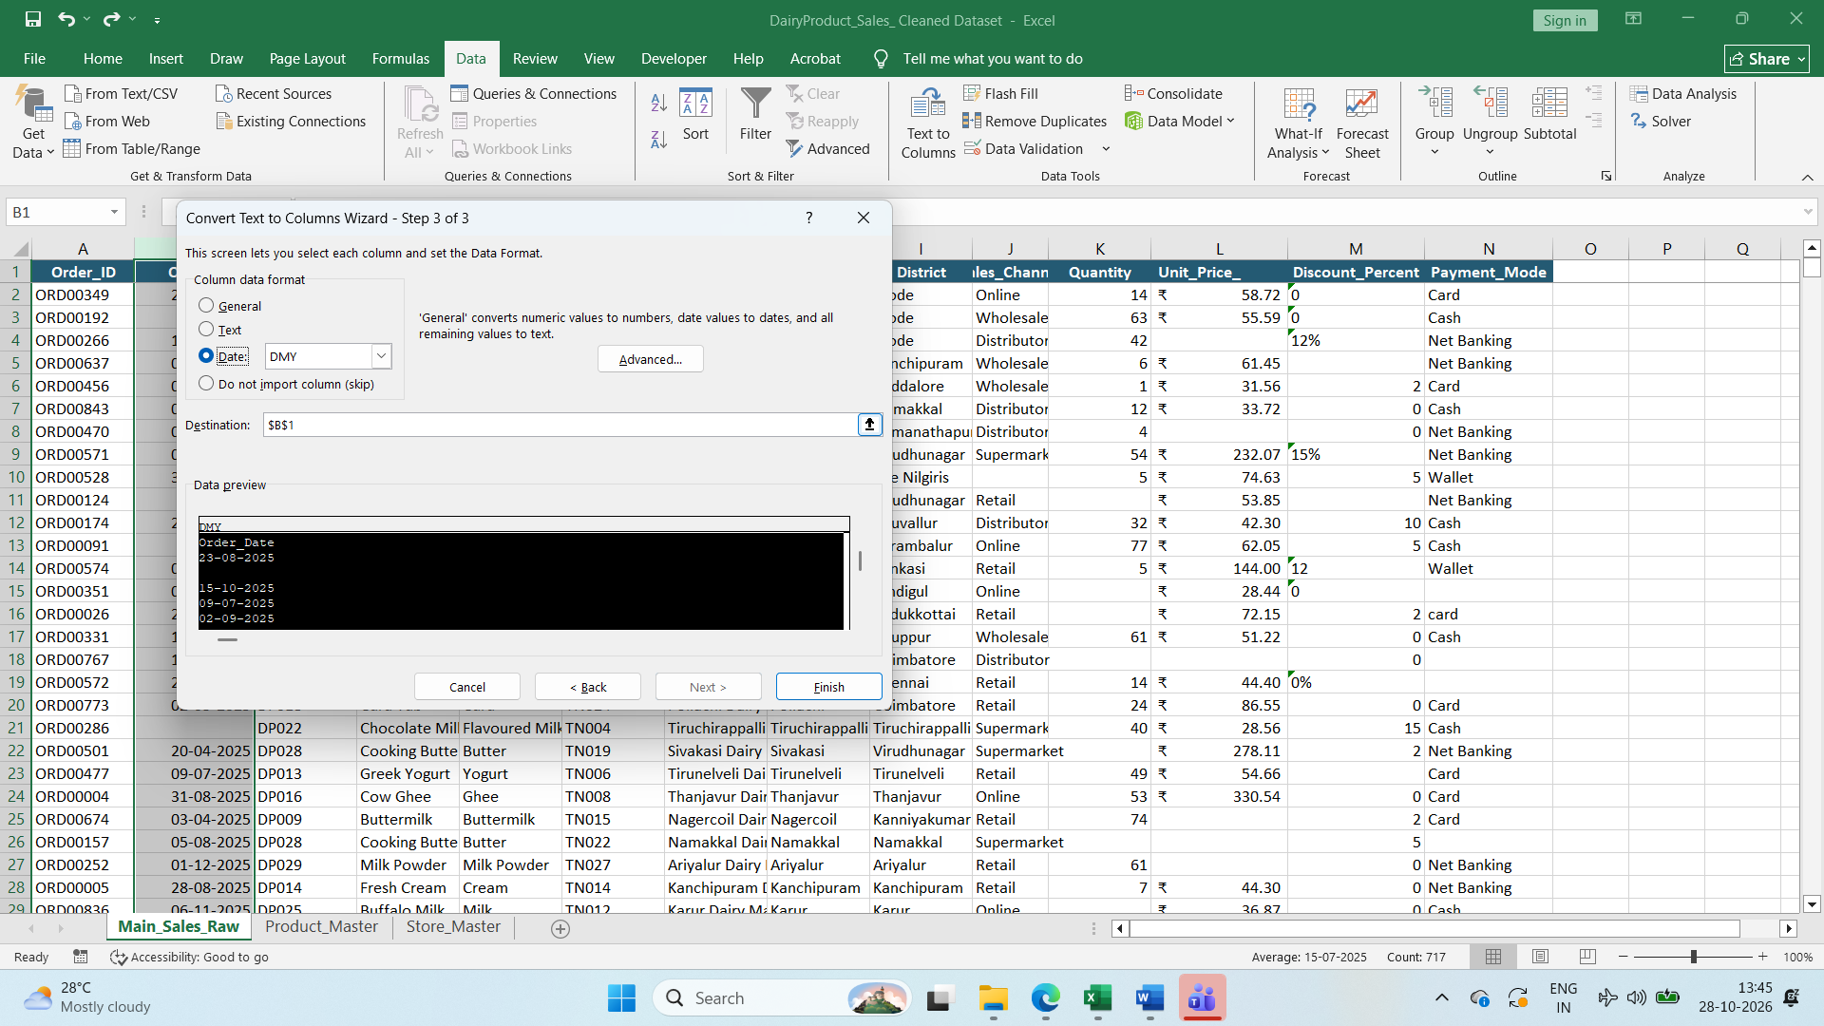
Using Text to column covert the date format into DMY format
Step13 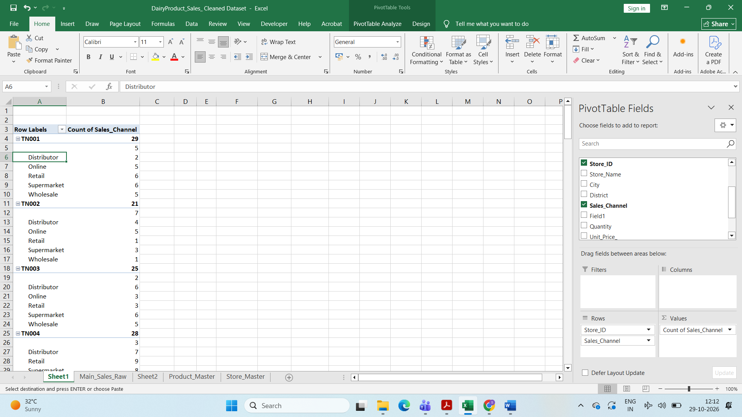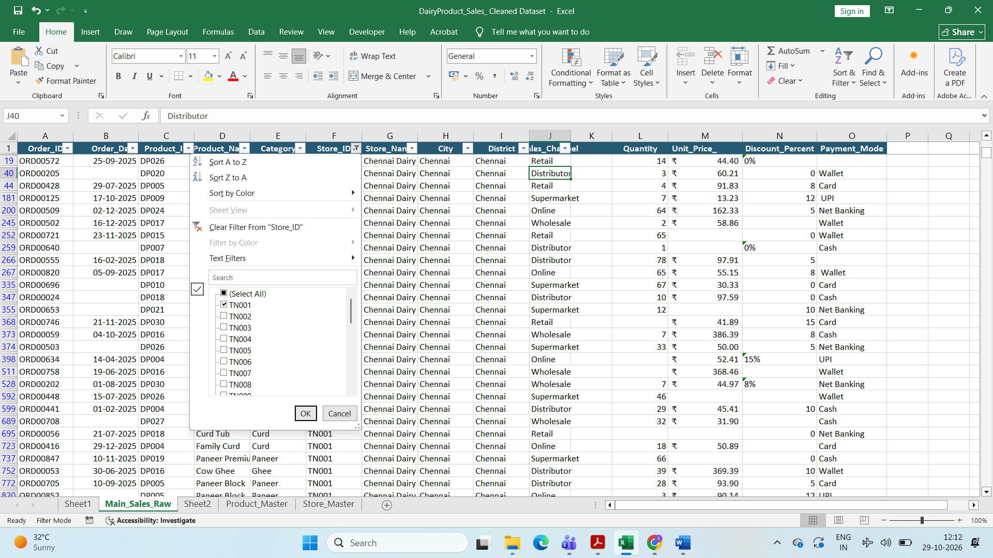
Used Pivot Table to find the most repeated sales channel in store ID wise and used filter to fill the blank columns with most repeated sales channel
Step14:
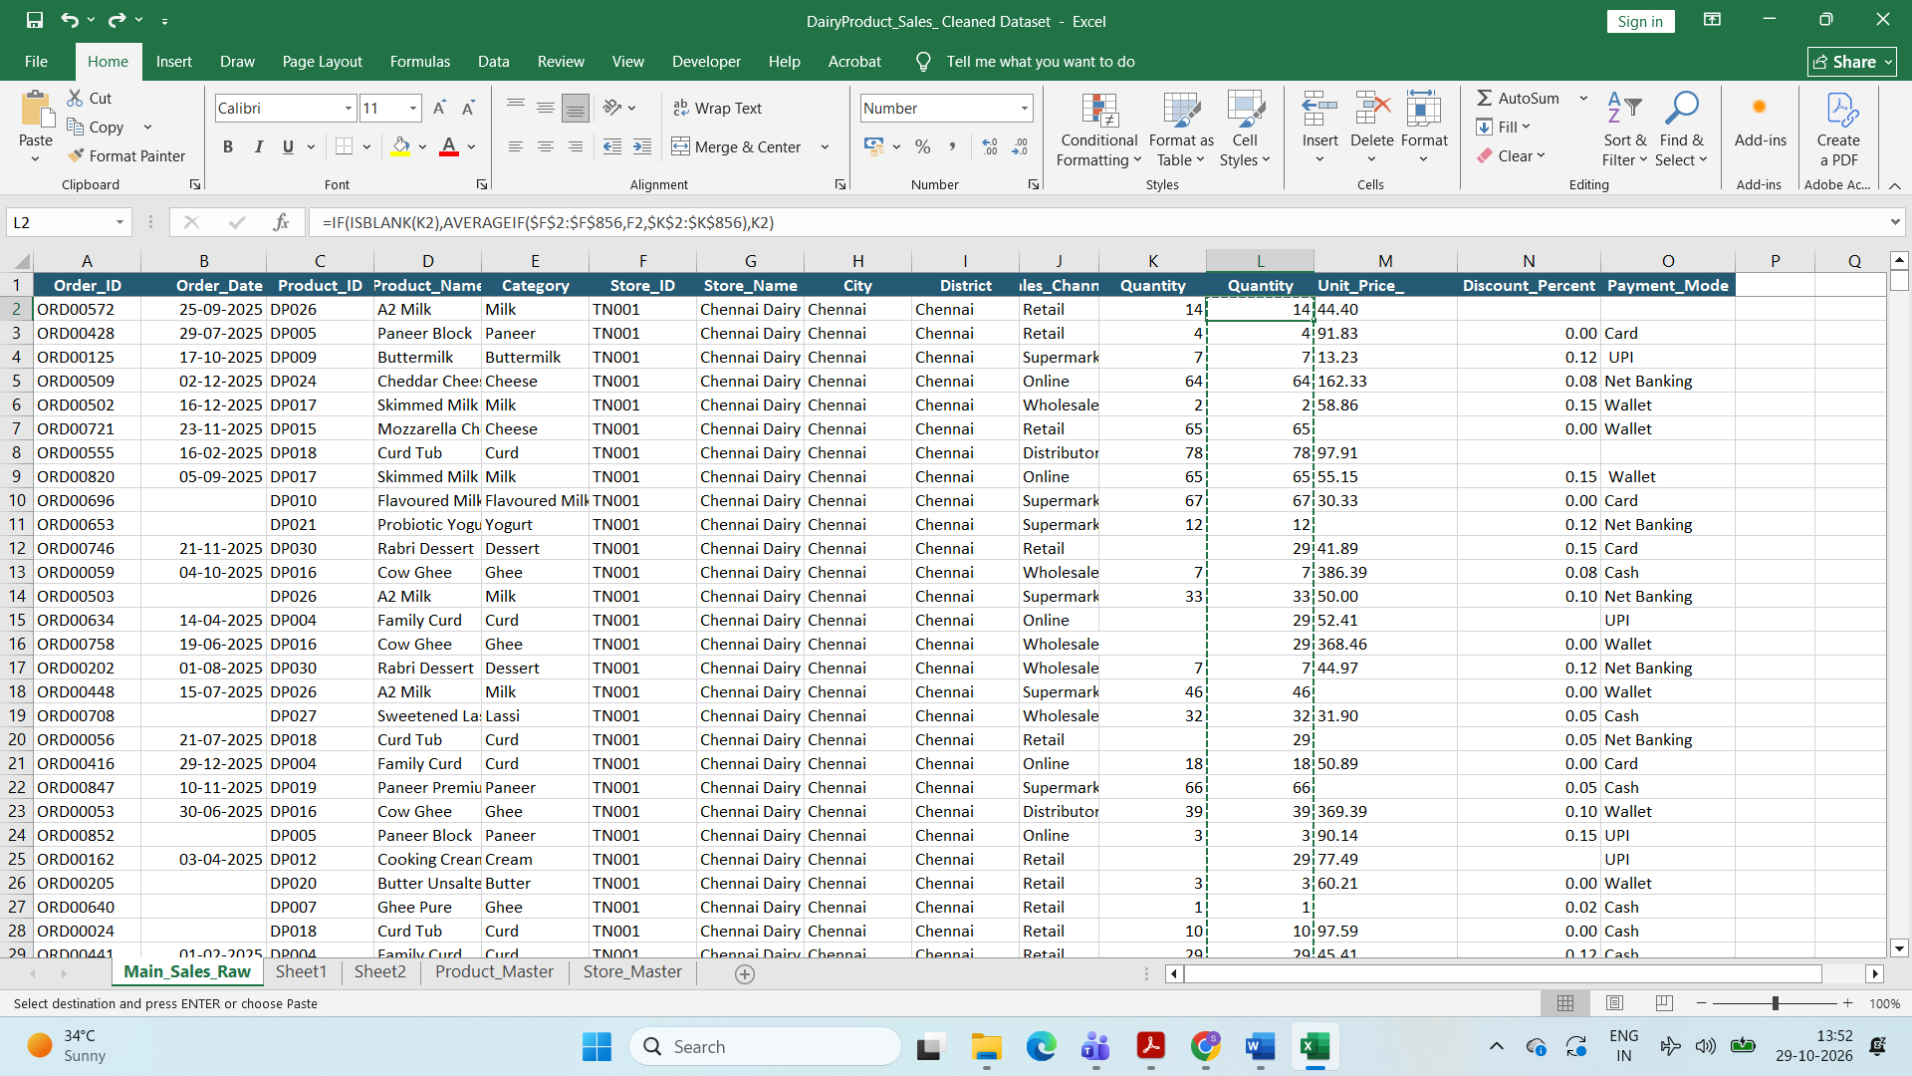
Finding Missed Quantity with isblank and average if =IF(ISBLANK(K2),AVERAGEIF($F$2:$F$856,F2,$K$2:$K$856),K2) and copy and paste special and deleted the existing column
Step15:
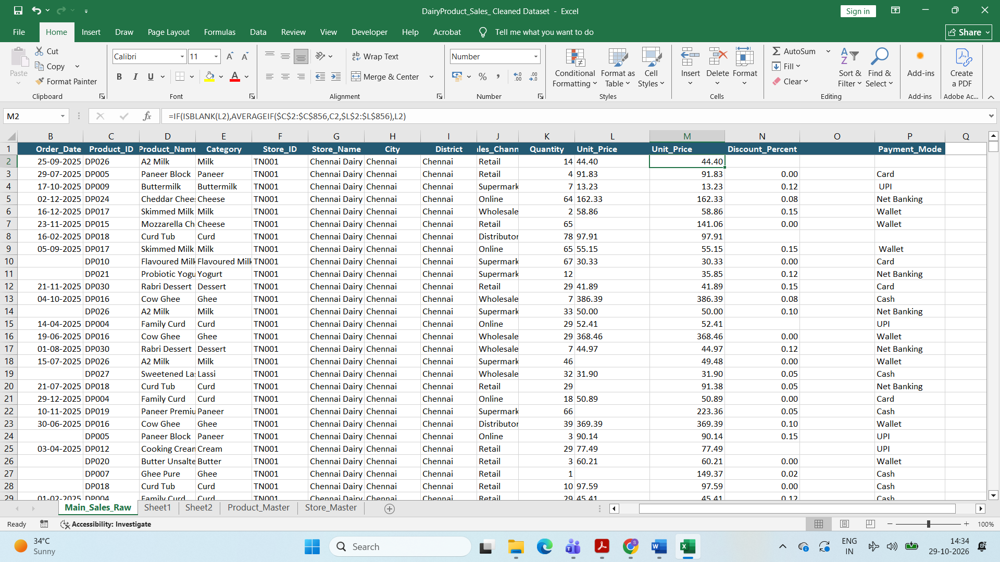
Finding Missed Unit Prioce with isblank and average if =IF(ISBLANK(L2),AVERAGEIF($C$2:$C$856,C2,$L$2:$L$856),L2) and copy and paste special and deleted the existing column
Step16:

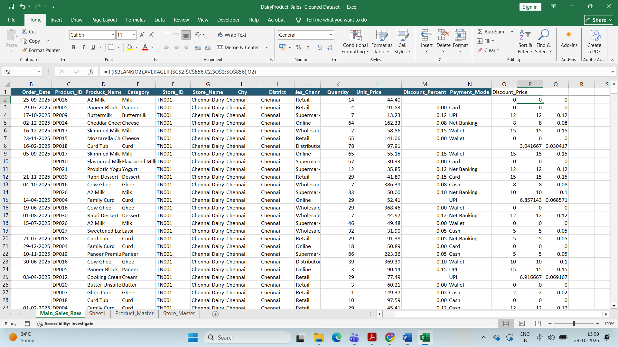
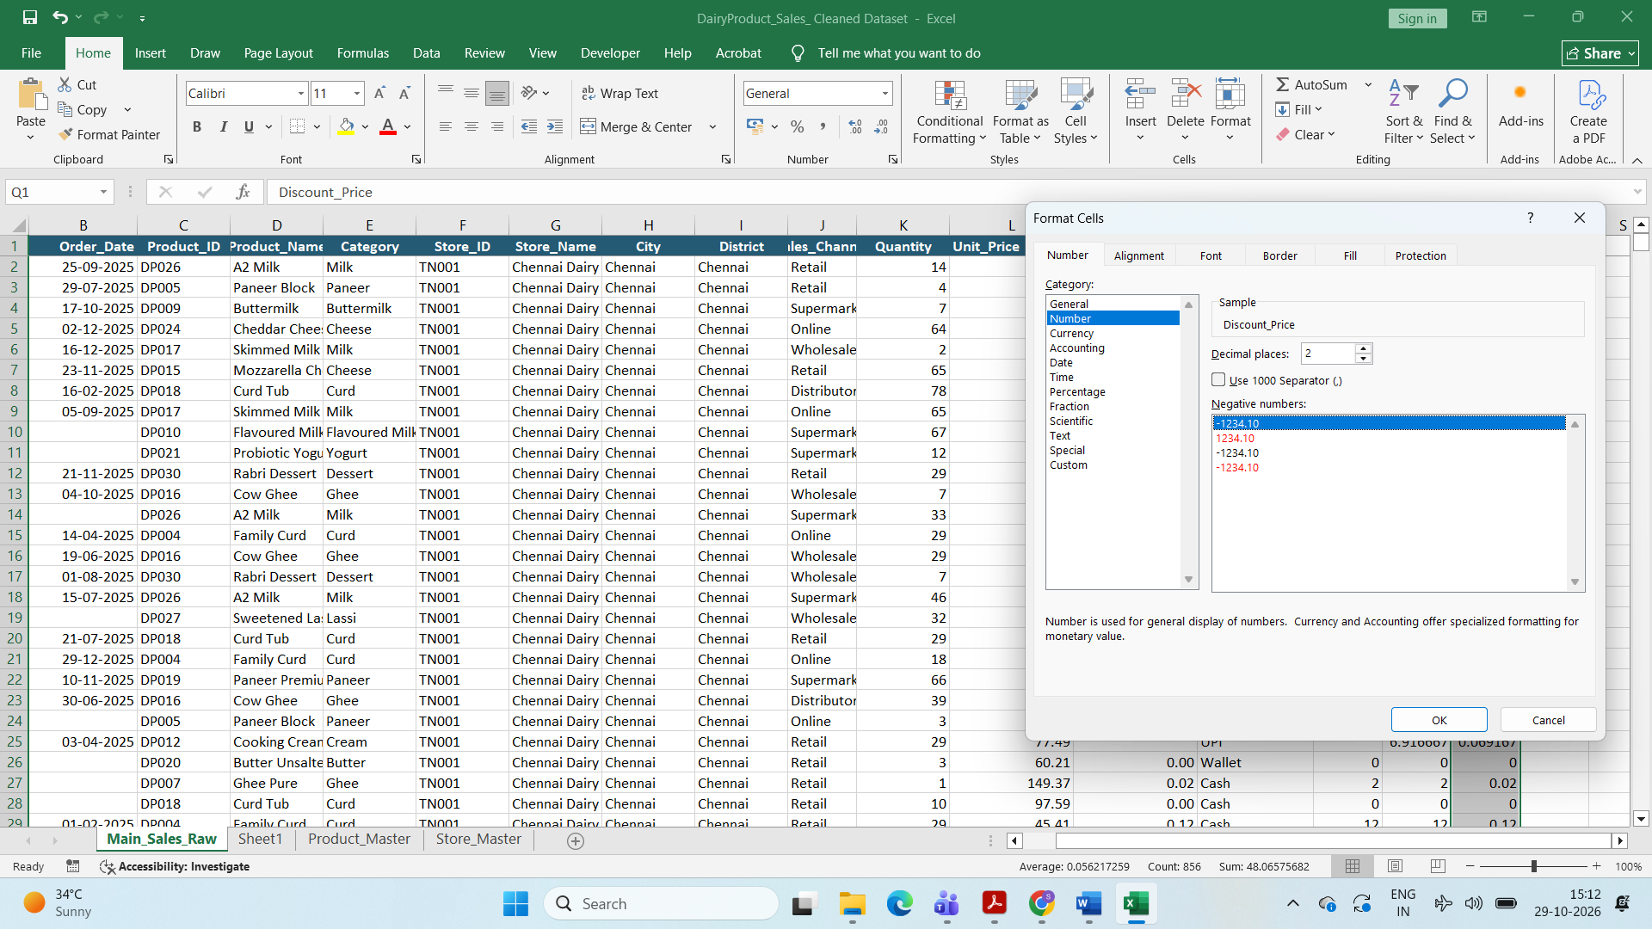
Finding the Missing Discount Percent
Create a new colum and multiply cells *100 and another column used formula =IF(ISBLANK(O2),AVERAGEIF($C$2:$C$856,C2,$O$2:$O$856),O2) and with that value another column /100
And convert the number into two decimal with format cells
Step18:
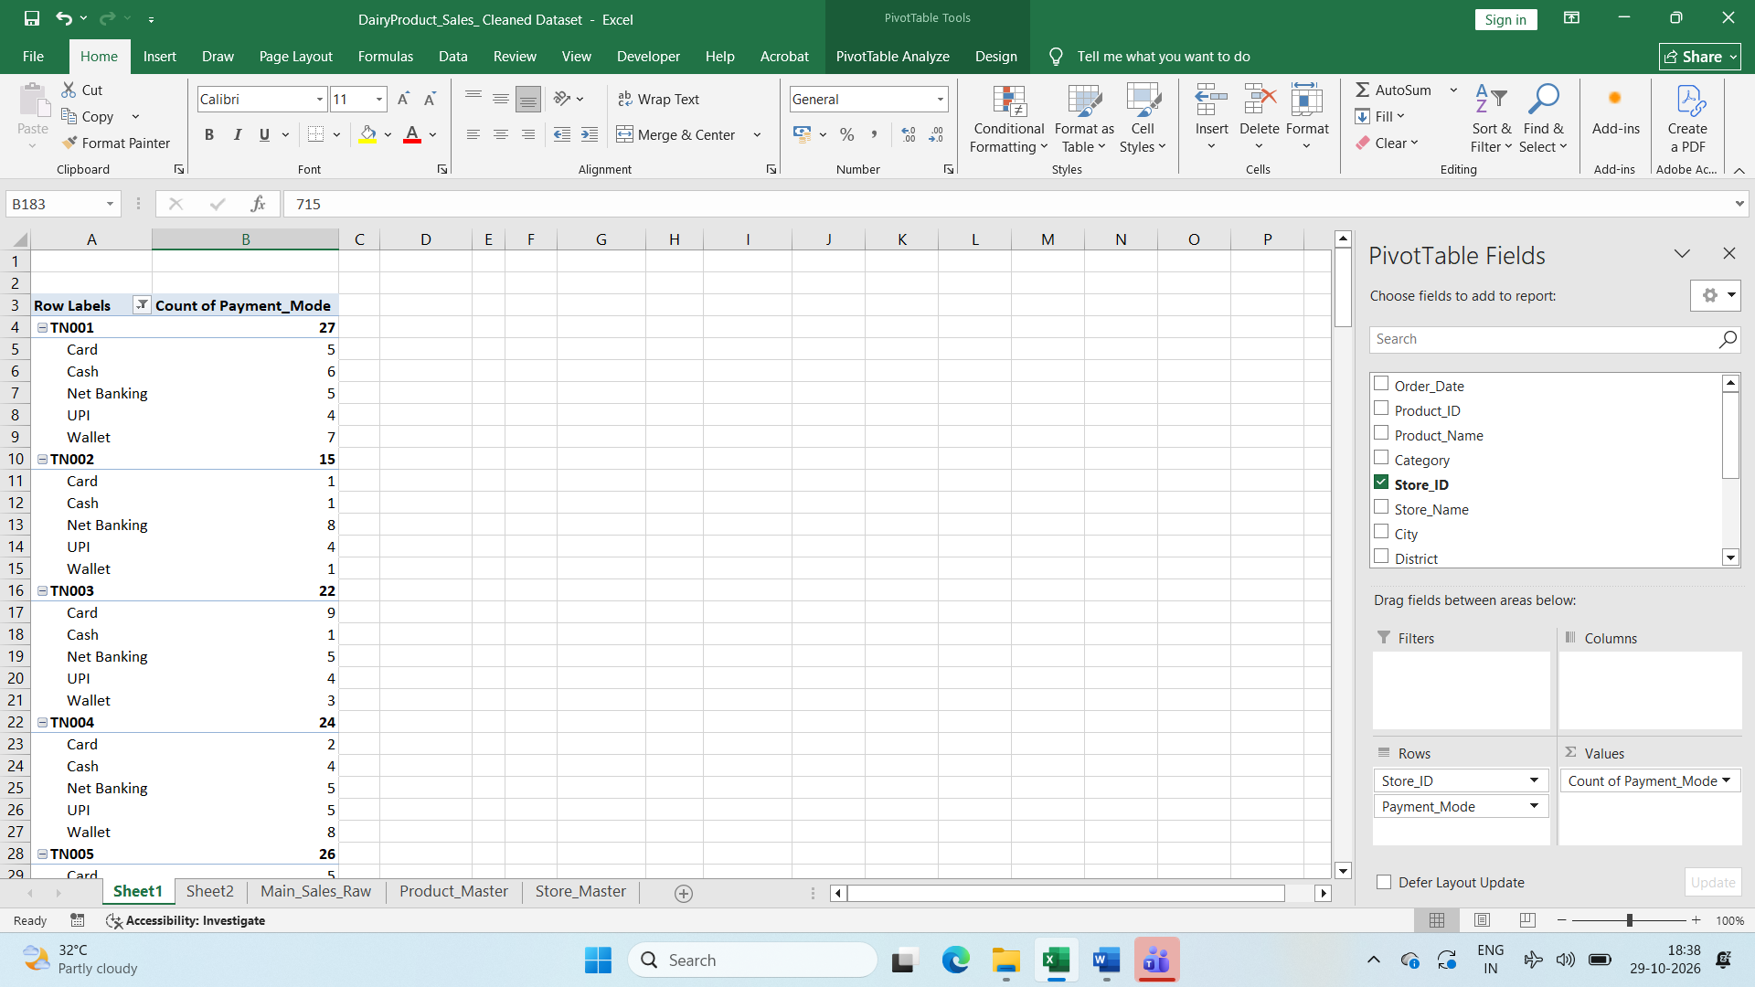
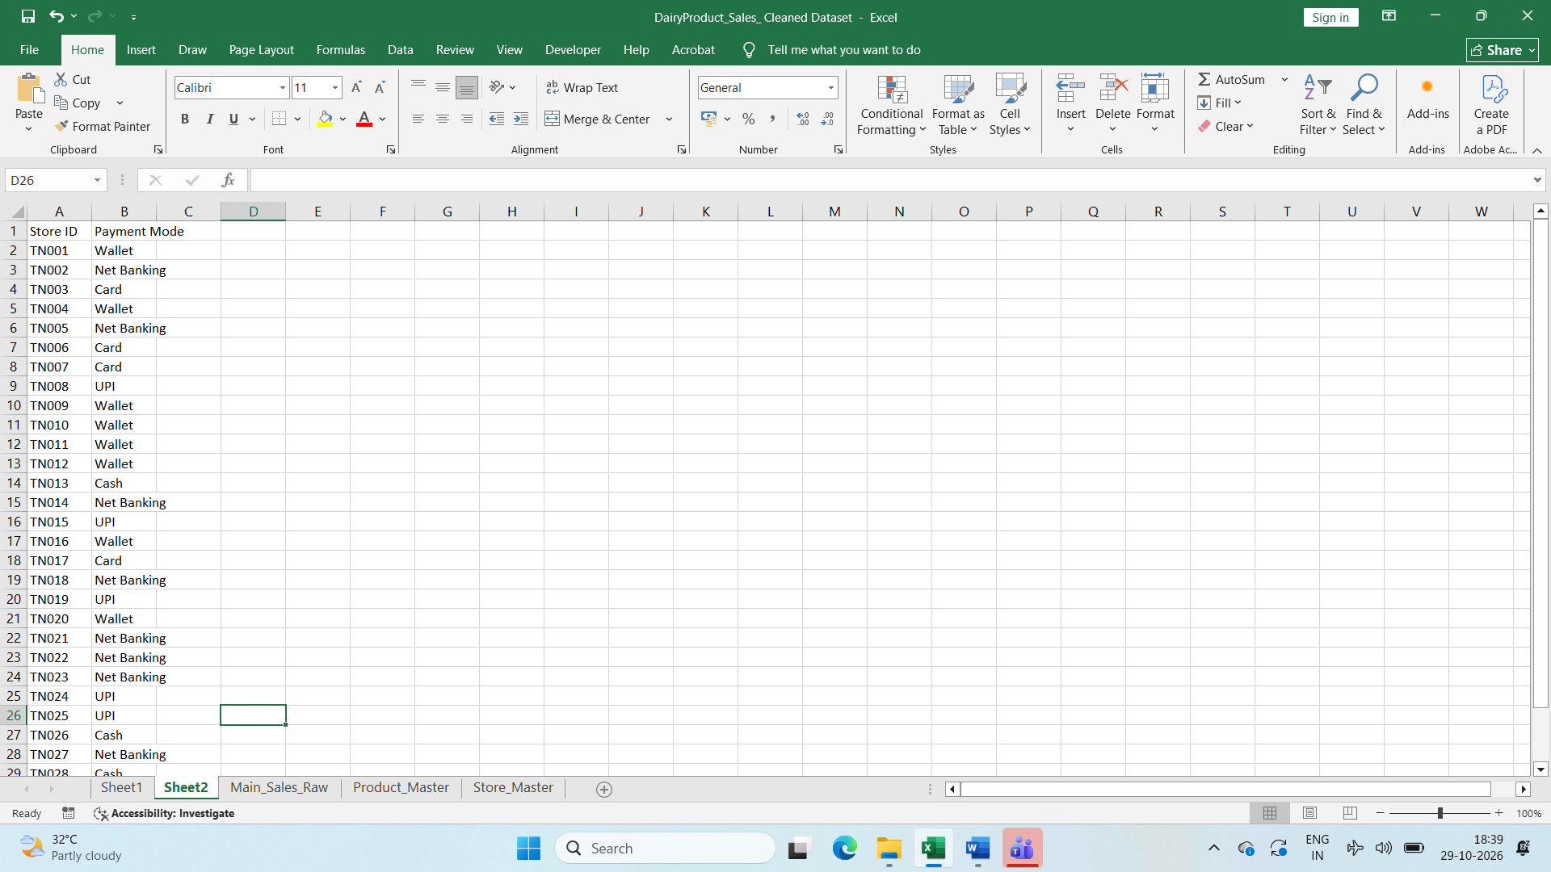
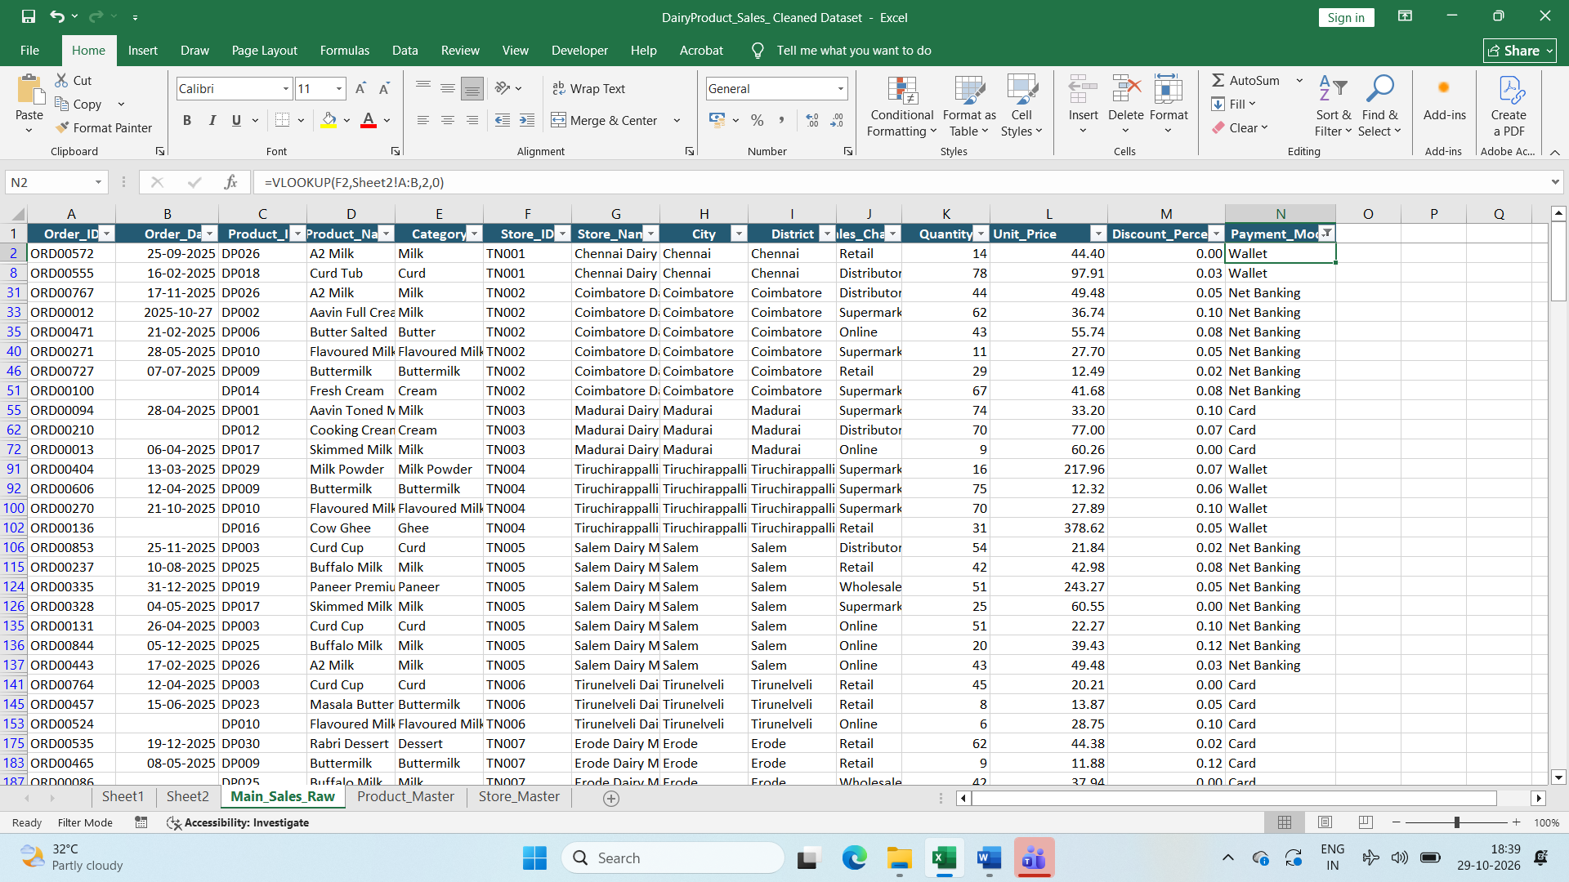
Finding the Missing payment Mode
First created Pivot Table with Store ID and Payment Mode to find the Repeated payment Mode store wise and then created new sheet with Store ID and Repeated Payment Mode
And filtered the blanks and used Vlookup to fill the Repeated payment and mode
Step19:
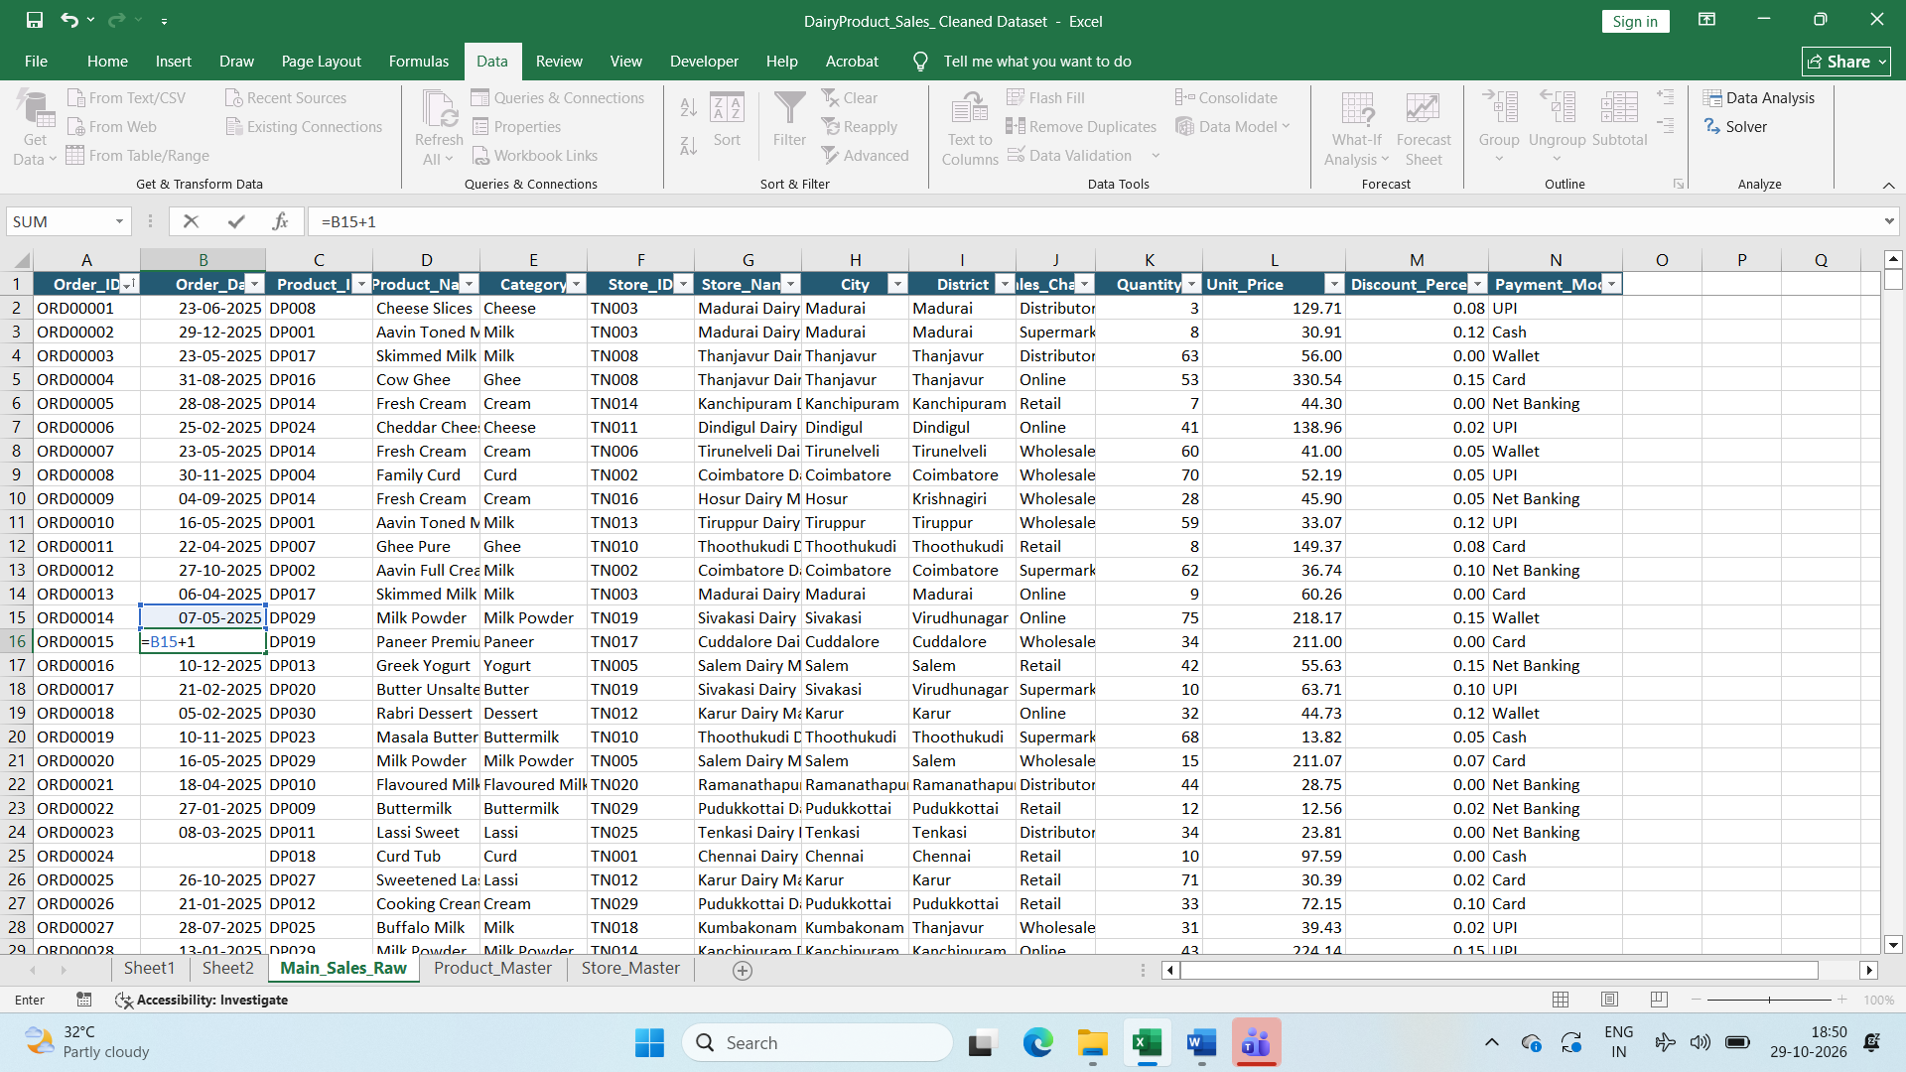
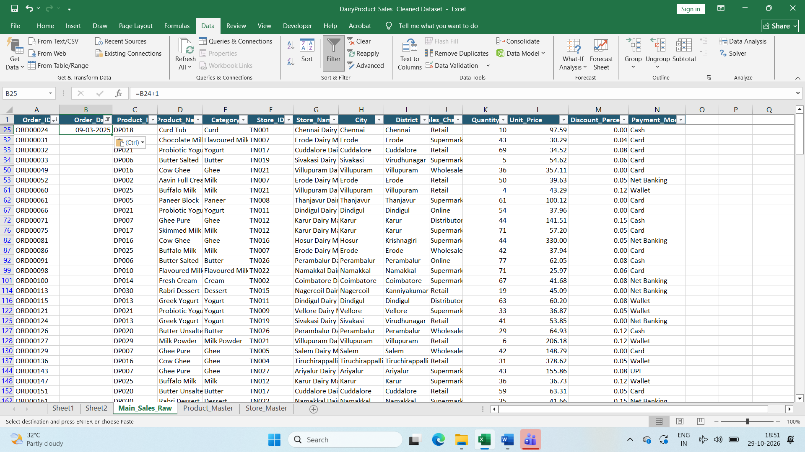
Finding the Missing Order Date
Sorted the Order ID asseding and filled the blank as previous date +1
Copy and pasted into all blank columns
Step20:
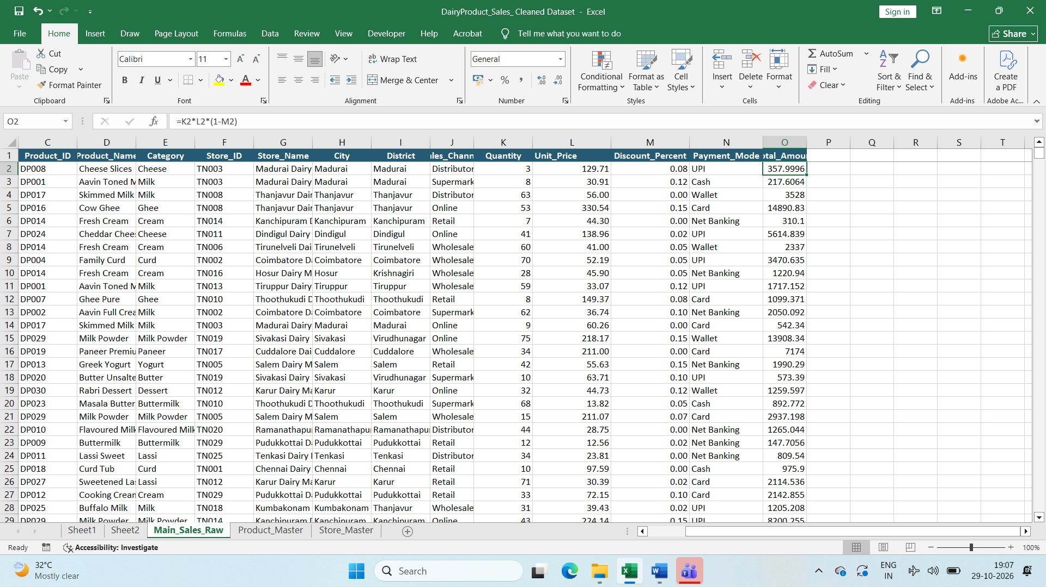
Finding Total Amount By calculation Quantity*UnitPrice*(1-Discount percent)
=K2*L2*(1-M2)
Step21:
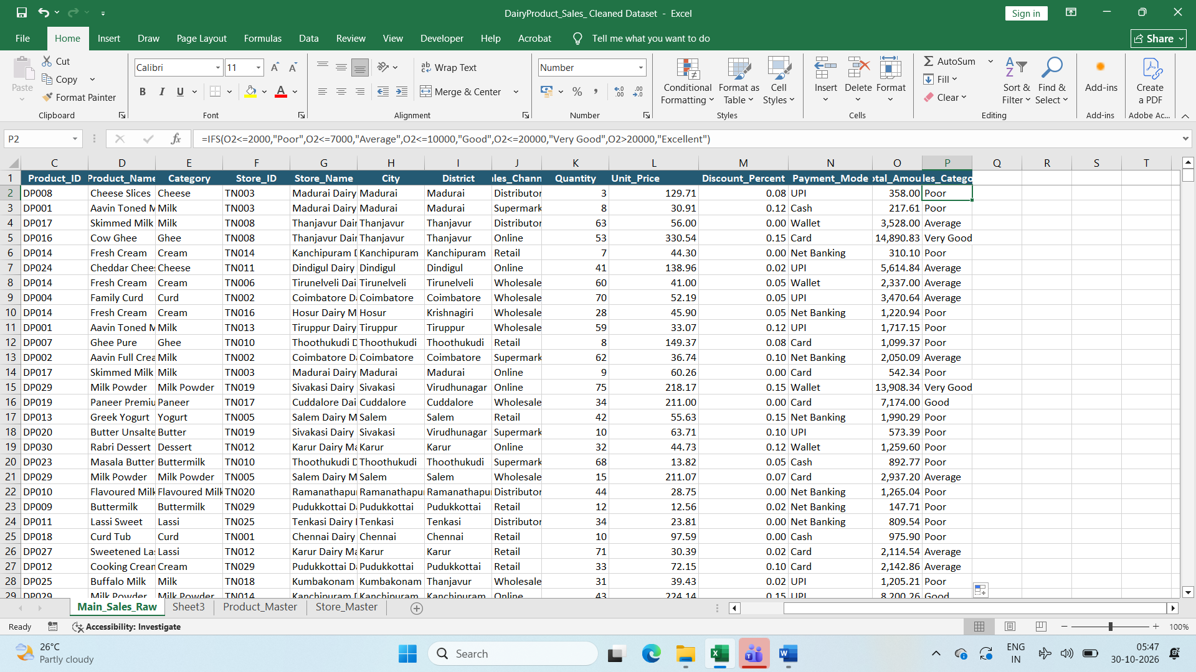
Created new column as Sales category and Using IFS function
=IFS(O2<=2000,"Poor",O2<=7000,"Average",O2<=10000,"Good",O2<=20000,"Very Good",O2>20000,"Excellent") to list category
Step22:
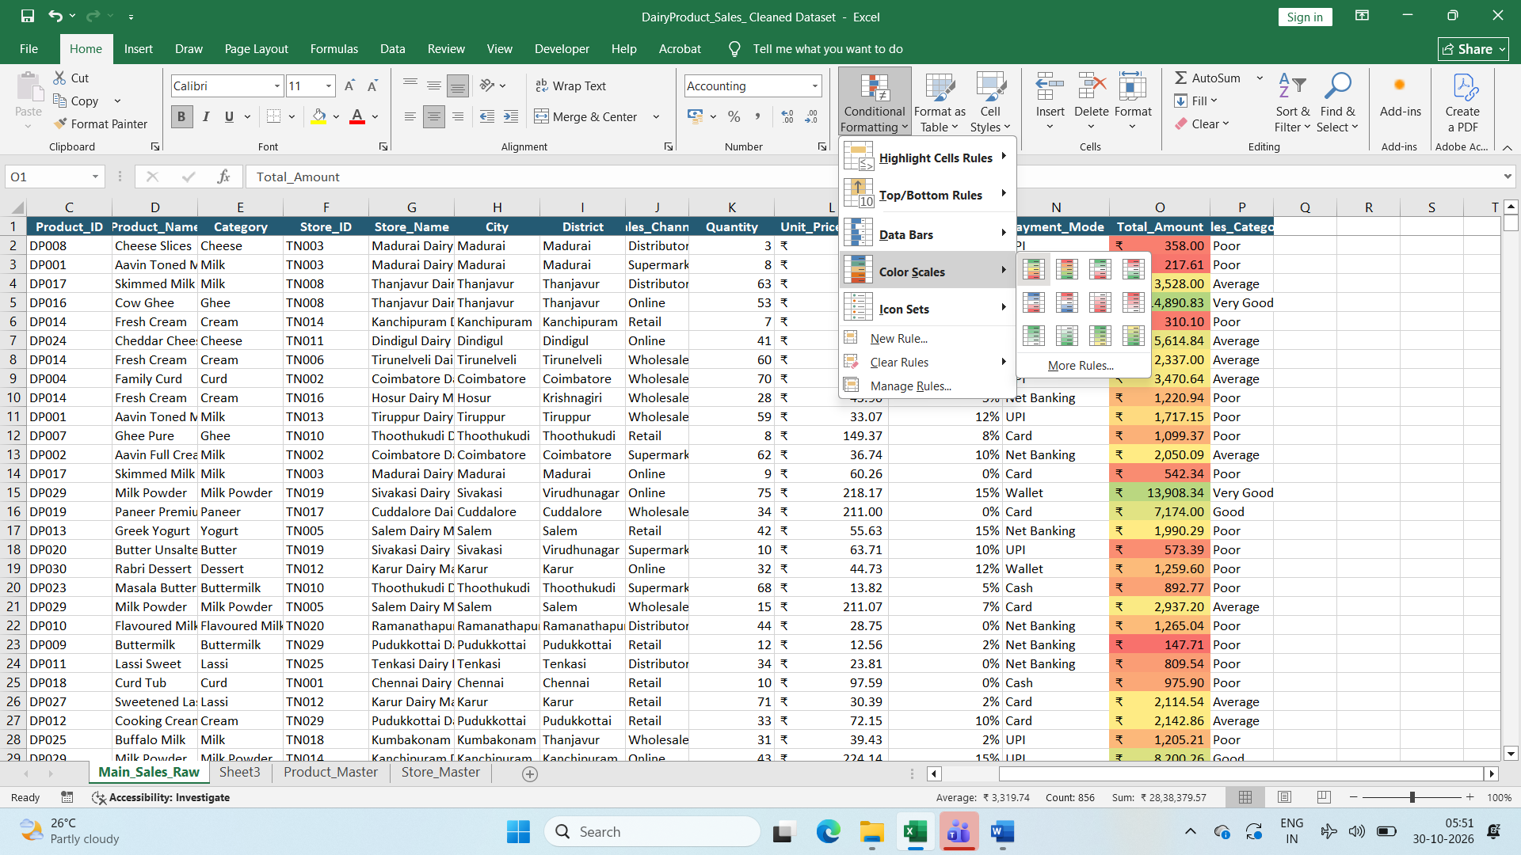
Used Color Scales for total Amount

